**COURSE-3**

**DATA SCIENCE METHODOLOGY**

**Module 1**

What is methodology?

* system of methods
* A guideline for decision making
* Guides the data scientists in solving complex problems with data

It includes:

* data collection
* creation of measurement strategies
* comparison of data analysis methods

General Methodology stages:  
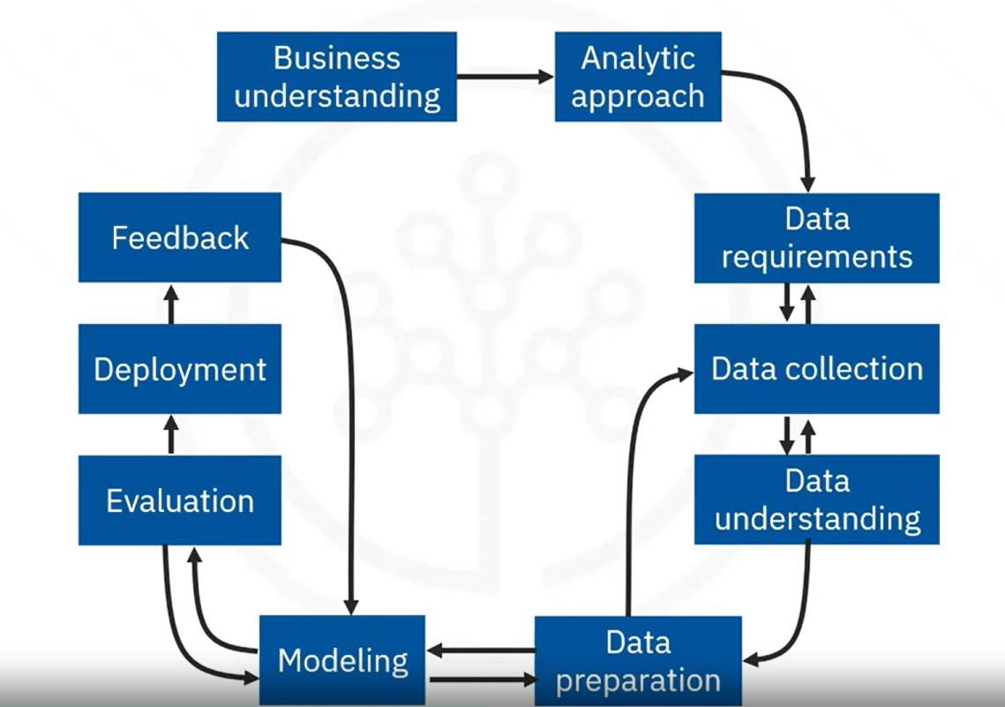

Sequence of questions used in this approach:  
1. What is the problem that you are solving?  
2. How can you use the data to answer business questions?  
3. What data do you need to answer the questions?  
4. Where is the data sourced from and how will you receive the data?  
5. Does the data collected represent the problem solved?  
6. What additional work is required to manipulate and work with the data?  
7. When you apply the data visualizations, do you see answers that address the business problem?  
8. Does the data model answer the initial business question, or adjusting the data is needed?  
9. Can u put the model into practice?  
10. Can you get constructive feedback from the data and stakeholder to answer the business question?

Stage 1: Business Understanding  
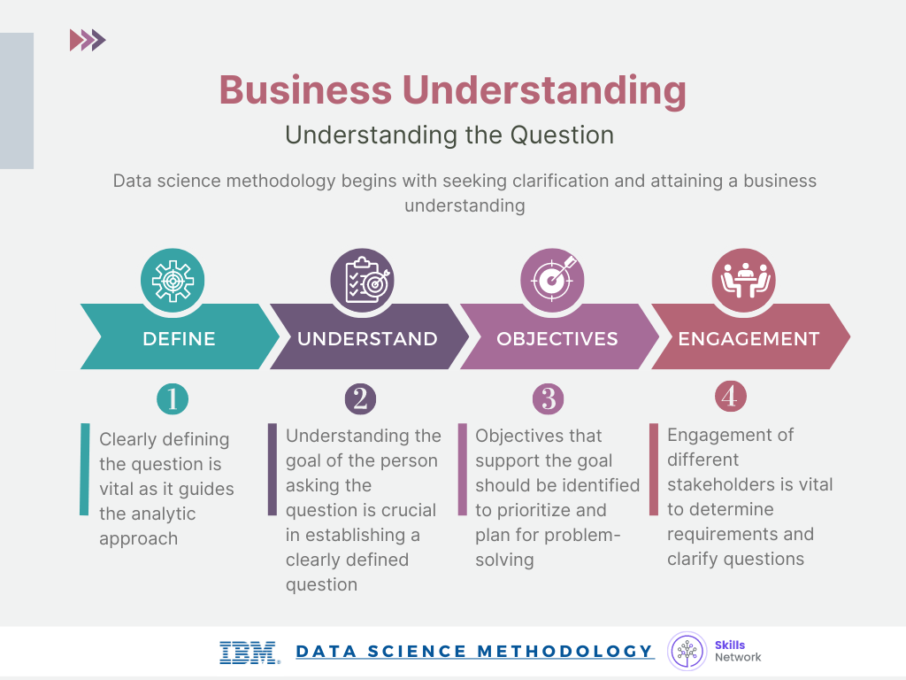

Stage 2: Analytic Approach  
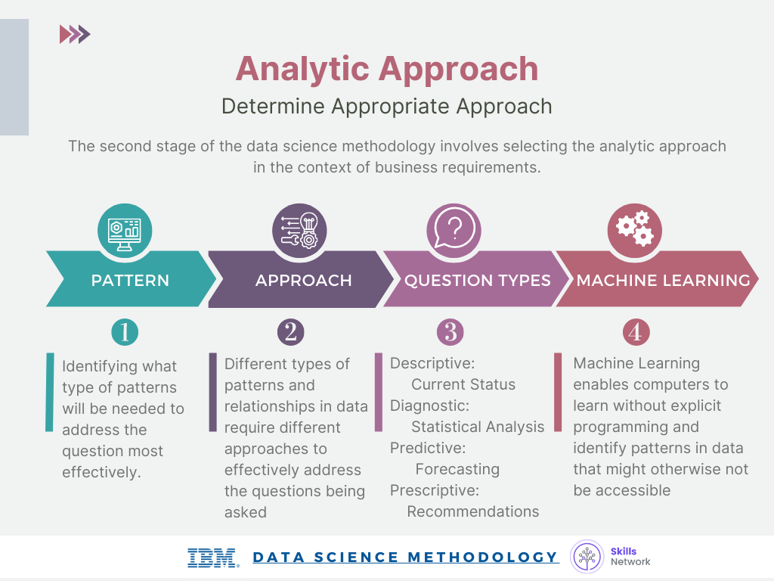

Stage 3: Data Requirements & Stage 4: Data Collection

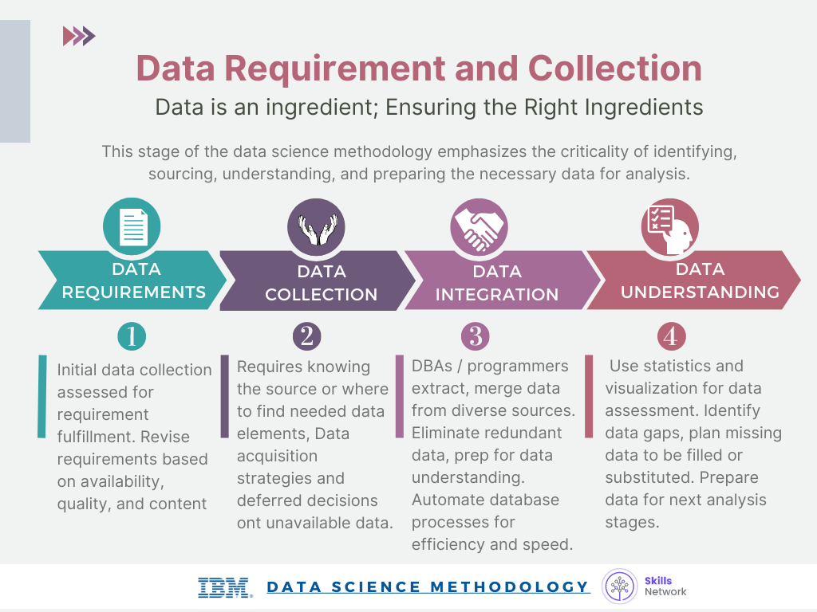

Stage 5: Data Understanding & Stage 6: Data Preparation 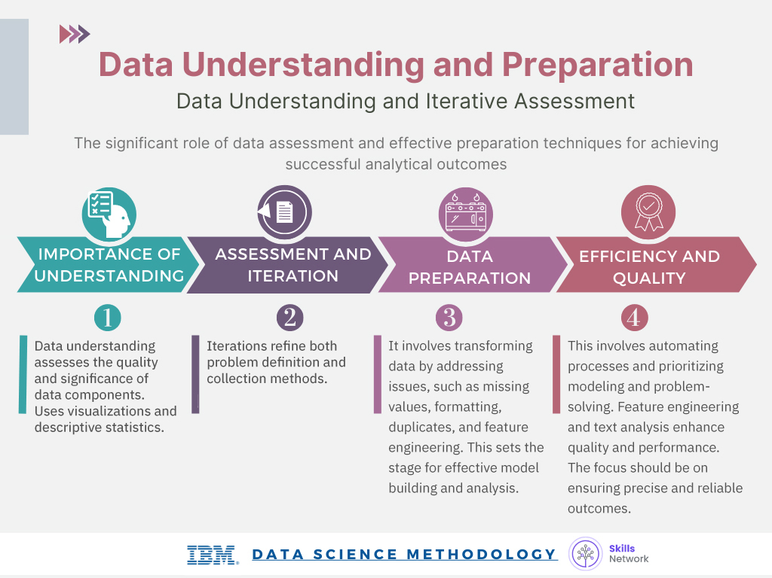

Stage 7:Modeling & Stage 8: Evaluation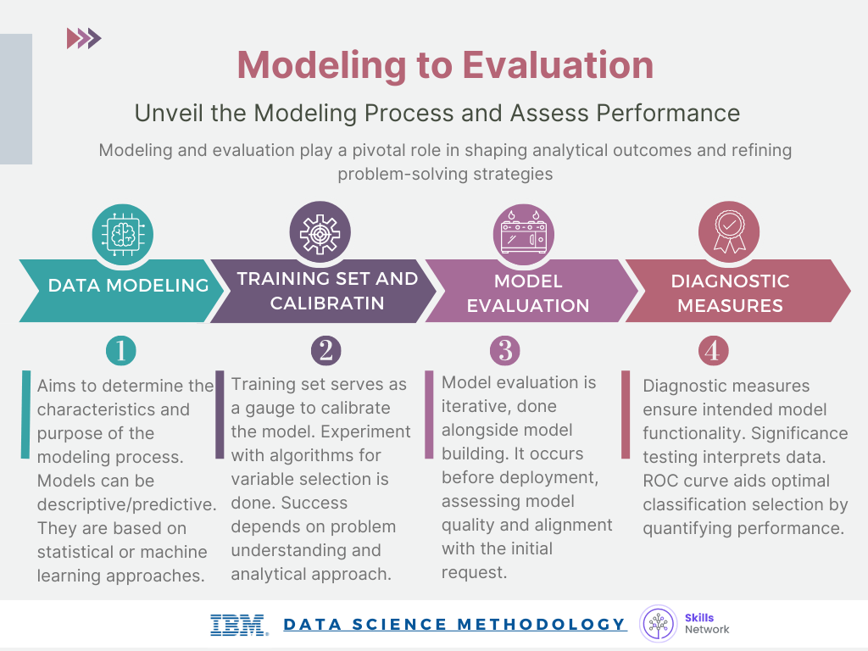

Stage 9: Deployment & Stage 10: Feedback